**What is WAF?**

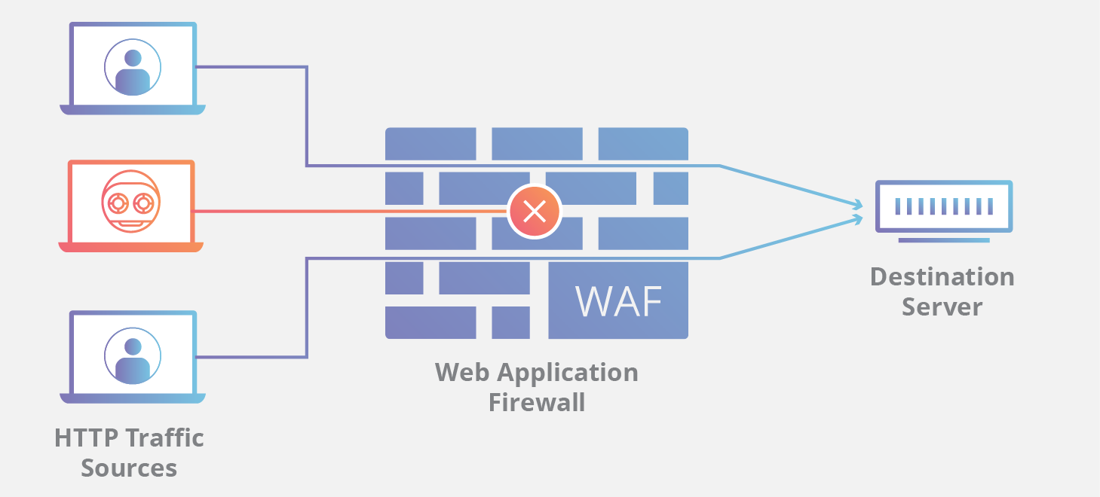

credit: Cloudflare

A ‘web application firewall (WAF)’ is a firewall for HTTP applications. A WAF operates through rules, often called policies, that aim to protect against application vulnerabilities by filtering out malicious traffic.

Deploying a WAF in front of a web application creates a shield between the application and the Internet. While a proxy server protects a client machine’s identity by using an intermediary, a WAF is a type of reverse proxy that protects the server from exposure by having clients pass through the WAF before reaching the server.

It protects web applications from various application layer attacks such as cross-site scripting (XSS), SQL injection, and cookie poisoning, among others. Attacks on apps are the leading cause of breaches — they are the gateway to your valuable data. With the right WAF in place, you can block the array of attacks that aim to exfiltrate that data by compromising your systems.

**How Does It Work?**

• A WAF protects your web apps by filtering, monitoring, and blocking any malicious HTTP/S traffic traveling to the web application, and prevents any unauthorized data from leaving the app. It does this by adhering to a set of policies that help determine what traffic is malicious and what traffic is safe. Just as a proxy server acts as an intermediary to protect the identity of a client, a WAF operates in a similar fashion but in the reverse — called a reverse proxy — acting as an intermediary that protects the web app server from a potentially malicious client.

• WAFs can come in the form of software, an appliance, or delivered service. Policies can be customized to meet the unique needs of your web application or set of web applications. Although many WAFs require you to update the policies regularly to address new vulnerabilities, advances in machine learning enable some WAFs to update automatically. This automation is becoming more critical as the threat landscape continues to grow in complexity and ambiguity.

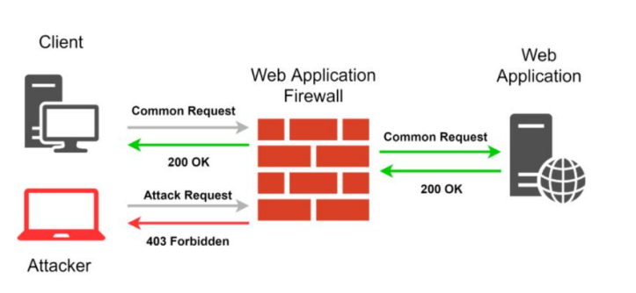

**Types:**

*❖****A network-based****WAF is generally called hardware-based. Since they are installed locally they minimize latency, but network-based WAFs are the most expensive option and also require the storage and maintenance of physical equipment.*

*❖****A host-based****WAF may be fully integrated into an application’s software also called software-based. This solution is less expensive than a network-based WAF and offers more customizability. The downside of a host-based WAF is the consumption of local server resources, implementation complexity, and maintenance costs. These components typically require engineering time and may be costly.*

*❖****Cloud-based****WAFs offer an affordable option that is very easy to implement; they usually offer a turnkey installation that is as simple as a change in DNS to redirect traffic. Cloud-based WAFs also have a minimal upfront cost, as users pay monthly or annually for security as a service. Cloud-based WAFs can also offer a solution that is consistently updated to protect against the newest threats without any additional work or cost on the user’s end.*

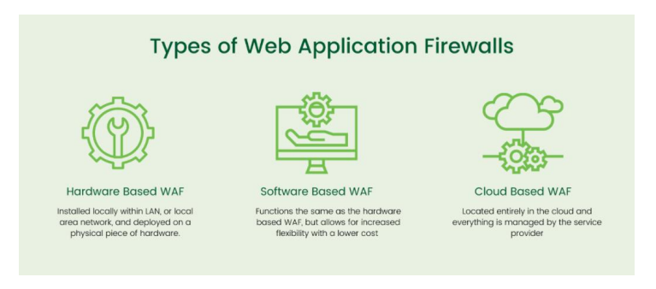

**Advantages Of WAF:**

A WAF has an advantage over traditional firewalls because it offers greater visibility into sensitive application data that is communicated using the HTTP application layer. It can prevent application layer attacks that normally bypass traditional network firewalls, including the following:

*▪ Cross-site scripting (XSS) attacks enable attackers to inject and execute malicious scripts in another user’s browser.*

*▪ Structured Query Language (SQL) injection attacks can affect any application that uses an SQL database and enables attackers to access and potentially change sensitive data.*

*▪ Web session hacking enables attackers to hijack a session ID and masquerade as an authorized user. A session ID is normally stored within a cookie or Uniform Resource Locator (URL).*

*▪ Distributed denial-of-service (DDoS) attacks overwhelm a network by flooding it with traffic until it is unable to serve its users. Both network firewalls and WAFs can handle this attack type but approach it from different layers.*

Another advantage of a WAF is that it can defend web-based applications without necessarily having access to the source code of the application. While a host-based WAF may be integrated into application code, a cloud-hosted WAF is capable of defending the application without having access. In addition, a cloud WAF is easy to deploy and manage and provides quick virtual patching solutions that enable users to rapidly customize their settings to adapt to newly detected threats.

**Importance:**

A WAF is important to the growing number of enterprises that provide products over the internet — including online bankers, social media platform providers, and mobile application developers — because it helps prevent data leakage. A lot of sensitive data, such as credit card data and customer records, is stored in back-end databases that are accessible through web applications. Attackers frequently target these applications to gain access to the associated data.

**WAF vs Firewall & IPS:**

An IPS is an intrusion prevention system, a WAF is a web application firewall, and an NGFW is a next-generation firewall. What’s the difference between them all?

An IPS is a more broadly focused security product. It is typically signature and policy-based — meaning it can check for well-known vulnerabilities and attack vectors based on a signature database and established policies. The IPS establishes a standard based on the database and policies and then sends alerts when any traffic deviates from the standard. The signatures and policies grow over time as new vulnerabilities are known. In general, IPS protects traffic across a range of protocol types such as DNS, SMTP, TELNET, RDP, SSH, and FTP. IPS typically operates and protects layers 3 and 4. The network and session layers although some may offer limited protection at the application layer (layer 7).

A next-generation firewall (NGFW) monitors the traffic going out to the Internet — across websites, email accounts, and SaaS. Simply put, it’s protecting the user (vs the web application). An NGFW will enforce user-based policies and add context to security policies in addition to adding features such as URL filtering, anti-virus/anti-malware, and potentially its intrusion prevention systems (IPS). While a WAF is typically a reverse proxy (used by servers), NGFWs are often forward proxy (used by clients such as a browser).

A web application firewall (WAF) protects the application layer and is specifically designed to analyze each HTTP/S request at the application layer. It is typically user, session, and application-aware, cognizant of the web apps behind it and what services they offer. Because of this, you can think of a WAF as the intermediary between the user and the app itself, analyzing all communications before they reach the app or the user. Traditional WAFs ensure that only allowed actions (based on security policy) can be performed. For many organizations, WAFs are a trusted, first line of defense for applications, especially to protect against the OWASP Top 10 — the foundational list of the most seen application vulnerabilities. This Top 10 currently includes:

*• Injection attacks*

*• Broken Authentication*

*• Sensitive data exposure*

*• XML External Entities (XXE)*

*• Broken Access control*

*• Security misconfigurations*

*• Cross-Site Scripting (XSS)*

*• Insecure Deserialization*

**WAF Mitigation:**

So how, exactly, does a WAF mitigate all those vulnerabilities? There are three primary methods a WAF uses to detect and prevent web attacks: deny/allow requests, inspect and reject, and signatures. Let’s explore each, shall we?

➢ Deny/Allow Requests

*The deny/allow requests method is very much like the traditional doorway model used by network firewalls. Requests are either denied or allowed based on available information. That information might be simple — like an IP address — or it might be more complex and specific to HTTP, like OPTIONS or METHODS.*

➢ Signatures

*Signatures are another method of protection common to many different security solutions. Anti-virus and anti-malware services rely on signatures that enable them to quickly scan for evidence of viruses and malware and flag them. IPS/IDS, too, rely heavily on this method, as do WAF. There are two kinds of signatures: user-defined and vendor-managed.*

➢ Inspection

*Finally, inspection is included to ensure complete control over requests (and responses). Inspection of requests allows the WAF to compare information in the request against known good/bad strings and values to determine whether the request is malicious or legitimate. For HTTP applications (which means most of them on the Internet today) this is the most important capability a WAF should provide. If a WAF does not offer programmable inspection, you’ll want to reconsider that choice. Because HTTP is text-based and extensible, there is virtually no way to provide a comprehensive “checkbox” list of options and methods that you can use to inspect requests. Very few HTTP headers have restricted options, making it very difficult to limit what can and cannot be stuffed into it. That means inspection is often required to sniff out malicious code embedded in headers or in the payload itself. There are two ways to use inspection: known headers and payload.*

**Techniques to Bypass WAF:**

➢ Case Toggling Technique

*Combine upper and lower case characters to create efficient payloads.*

*<ScrIpT>confirm()</sCRiPt>*

➢ Using Comments Technique

*Comments obfuscate standard payload vectors. Different payloads have different ways of obfuscation.*

*<! →<script>confirm/**/()/**/</script>*

*sELecT * FrOm all_tables whERe OWNER = ‘DATABASE_NAME’*

➢ Null Character Injection

*Inject %00 in the parameter before malicious input. WAFs will commonly ignore everything after the null but pass the entire string to the web server where it is processed.*

➢ Mixed Case

*Change case of malicious input triggering WAF protections. <script> may become <sCRiPt> If the WAF is using a case-sensitive blacklist, changing the case may bypass that filter.*

➢ Inline Comments

*Insert comments in the middle of attack strings. For instance, /*!SELECT*/ might be overlooked by the WAF but passed on to the target application and processed by a MySQL database.*

*Blocked: Bypassed:*

*Blocked: /?id=1+union+select+1,2,3 — Bypassed: /?id=1+un/**/ion+sel/**/ect+1,2,3 —*

➢ Buffer Overflow

*WAFs are, after all, applications and are vulnerable to the same software flaws as any other application. If a buffer overflow condition can create a crash, even if it does not result in code execution, this may result in a WAF failing to open. In other words, a bypass.*

➢ HTTP Parameter

*Pollution Supply multiple parameter= value sets of the same name to confuse the WAF. Given the example http://example.com?id=1&?id=’ or ‘1’=’1′ — ‘ in some circumstances such as with Apache/PHP, the application will only parse the last (second) instance of id= while the WAF only parses the first. It appears to be a legitimate request but the application still receives and processes malicious input. Most WAFs today are not vulnerable to HTTP Parameter Pollution (HPP) but it is still worth a try when building bypasses.*

➢ URL encoding (hex)

*Use the hex equivalent for certain characters such as %27 for ‘ or %3c for <. This alone may not be sufficient for many modern WAFs but frequently works for application black-list filters as they may not be canonicalized before evaluation. Like many other techniques here, when combined with other methods is more effective.*

*Blocked: alert() Obfuscated: %253Cscript%253Ealert()%253C%252Fscript%253E*

➢ Keyword Splitting

*(Insert special characters that will be removed by WAF) — SELECT may become SEL<ECT which would be passed on as SELECT once the offending character is removed.*

➢ Replaced Keywords

*Similar to Keyword Splitting by wrapping a keyword around itself. For instance, SELSELECT becomes SELECT once the inner SELECT is removed.*

➢ Ignoring Cookies

*Ignore tracking cookies WAF sets to flag you as a “Bad User”. This can easily be configured using a regex match in Burp to ignore those cookies.*

➢ WAF Auto-Learning

*Many WAFs have a threshold whereby if they see n number of violations from different IP addresses within a specified window, it “un-learns” that rule and effectively disables it.*

➢ Using Data

*URIs Offending strings can be encoded as data URIs which are interpreted by the browser but may not be properly normalized by the WAF. This is very useful for client-side attacks like XSS.*

➢ Double Encoding Often

*WAF filters tend to encode characters to prevent attacks. However, poorly developed filters (no recursion filters) can be bypassed with double encoding.*